构造7行x5列的英文字母点阵字库

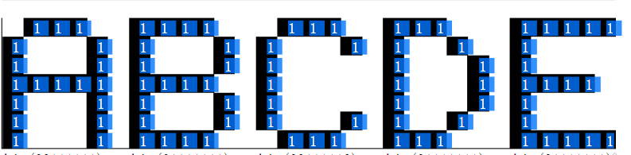

01110 0E 11110 1E 01110 0E 11100 1C 11111 1F

10001 11 10001 11 10001 11 10010 12 10000 10

10001 11 10001 11 10000 10 10001 11 10000 10

11111 1F 11110 1E 10000 10 10001 11 11110 1E

10001 11 10001 11 10000 10 10001 11 10000 10

10001 11 10001 11 10001 11 10010 12 10000 10

10001 11 11110 1E 01110 0E 11100 1C 11111 1F

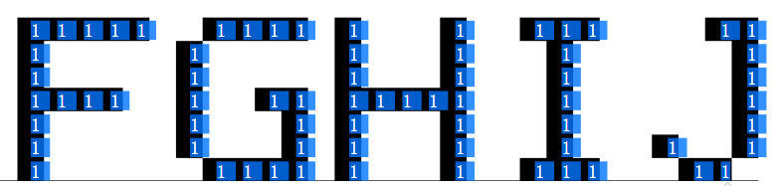

11111 1F 01111 0F 10001 11 01110 0E 00110 06

10000 10 10000 10 10001 11 00100 04 00010 02

10000 10 10000 10 10001 11 00100 04 00010 02

11110 1E 10011 13 11111 1F 00100 04 00010 02

10000 10 10001 11 10001 11 00100 04 00010 02

10000 10 10001 11 10001 11 00100 04 10010 12

10000 10 01111 0F 10001 11 01110 0E 01100 0C

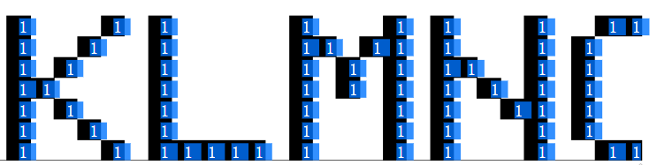

10001 11 10000 10 10001 11 10001 11 01110 0E

10010 12 10000 10 11011 1B 10001 11 10001 11

10100 14 10000 10 10101 15 11001 19 10001 11

11000 18 10000 10 10101 15 10101 15 10001 11

10100 14 10000 10 10001 11 10011 13 10001 11

10010 12 10000 10 10001 11 10001 11 10001 11

10001 11 11111 1F 10001 11 10001 11 01110 0E

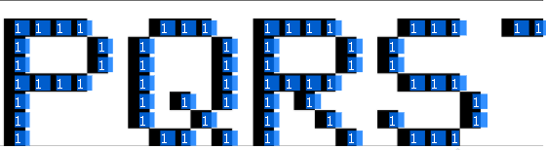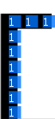

11110 1E 01110 0E 11110 1E 01110 0E 11111 1F

10001 11 10001 11 10001 11 10000 10 00100 04

10001 11 10001 11 10001 11 10000 10 00100 04

11110 1E 10001 11 11110 1E 01110 0E 00100 04

10000 10 10101 15 10100 14 00001 01 00100 04

10000 10 10010 12 10010 12 10001 11 00100 04

10000 10 01101 0D 10001 11 01110 0E 00100 04

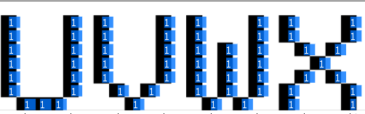

10001 11 10001 11 10001 11 10001 11

10001 11 10001 11 10001 11 10001 11

10001 11 10001 11 10101 15 01010 0A

10001 11 10001 11 10101 15 00100 04

10001 11 10001 11 10101 15 01010 0A

10001 11 01010 0A 10101 15 10001 11

01110 0E 00100 04 01010 0A 10001 11

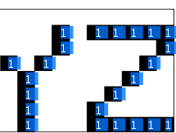

10001 11 11111 1F

10001 11 00001 01

01010 0A 00010 02

00100 04 00100 04

00100 04 01000 08

00100 04 10000 10

00100 04 11111 1F

public class StringPrint {

public static char character = '\*';

//大写英文字母是7行x5列的点阵，每行一个字节。

public static byte[] alphabet = {

0x0E,0x11,0x11,0x1F,0x11,0x11,0x11, //字母A的7个字节

0x1E,0x11,0x11,0x1E,0x11,0x11,0x1E, //字母B

0x0E,0x11,0x10,0x10,0x10,0x11,0x0E, //C

0x1C,0x12,0x11,0x11,0x11,0x12,0x1C, //D

0x1F,0x10,0x10,0x1E,0x10,0x10,0x1F, //E

0x1F,0x10,0x10,0x1E,0x10,0x10,0x10, //F

0x0F,0x10,0x10,0x13,0x11,0x11,0x0F, //G

0x11,0x11,0x11,0x1F,0x11,0x11,0x11, //H

0x0E,0x04,0x04,0x04,0x04,0x04,0x0E, //I

0x06,0x02,0x02,0x02,0x02,0x12,0x0C, //J

0x11,0x12,0x14,0x18,0x14,0x12,0x11, //K

0x10,0x10,0x10,0x10,0x10,0x10,0x1F, //L

0x11,0x1B,0x15,0x15,0x11,0x11,0x11, //M

0x11,0x11,0x19,0x15,0x13,0x11,0x11, //N

0x0E,0x11,0x11,0x11,0x11,0x11,0x0E, //O

0x1E,0x11,0x11,0x1E,0x10,0x10,0x10, //P

0x0E,0x11,0x11,0x11,0x15,0x02,0x0D, //Q

0x1E,0x11,0x11,0x1E,0x14,0x12,0x11, //R

0x0E,0x10,0x10,0x0E,0x01,0x11,0x0E, //S

0x1F,0x04,0x04,0x04,0x04,0x04,0x04, //T

0x11,0x11,0x11,0x11,0x11,0x11,0x0E, //U

0x11,0x11,0x11,0x11,0x11,0x0A,0x04, //V

0x11,0x11,0x15,0x15,0x15,0x15,0x0A, //W

0x11,0x11,0x0A,0x04,0x0A,0x11,0x11, //X

0x11,0x11,0x0A,0x04,0x04,0x04,0x04, //Y

0x1F,0x01,0x02,0x04,0x08,0x10,0x1F, //Z

};

public static void main(String[] args) {

// TODO Auto-generated method stub

// printString("HELLO");

printString("ABCDEFGHIJKLMNOPQRSTUVWXYZ");

}

public static void printString(String str) {

// 分解字符串的每一个字母，分别打印

char[] array = str.toCharArray();

for (char ch : array) {

//System.out.print(ch);

printCharacter2(ch);

}

}

public static void printCharacter2(char ch) {

int index = (ch-'A')\*7; //一个字母7个字节。

for(int i=0;i<7;i++){ //行循环

byte row = alphabet[index+i]; //取出每行的字节数据

byte mask = 0x10; //位掩码

for(int j=0;j<5;j++){

if( (row & (mask>>j))>0 ){

//对应的位为1，打印点。

System.out.print(character);

}else{

System.out.print(" ");

}

}

System.out.println();

}

}

}